Functionality Test: 1

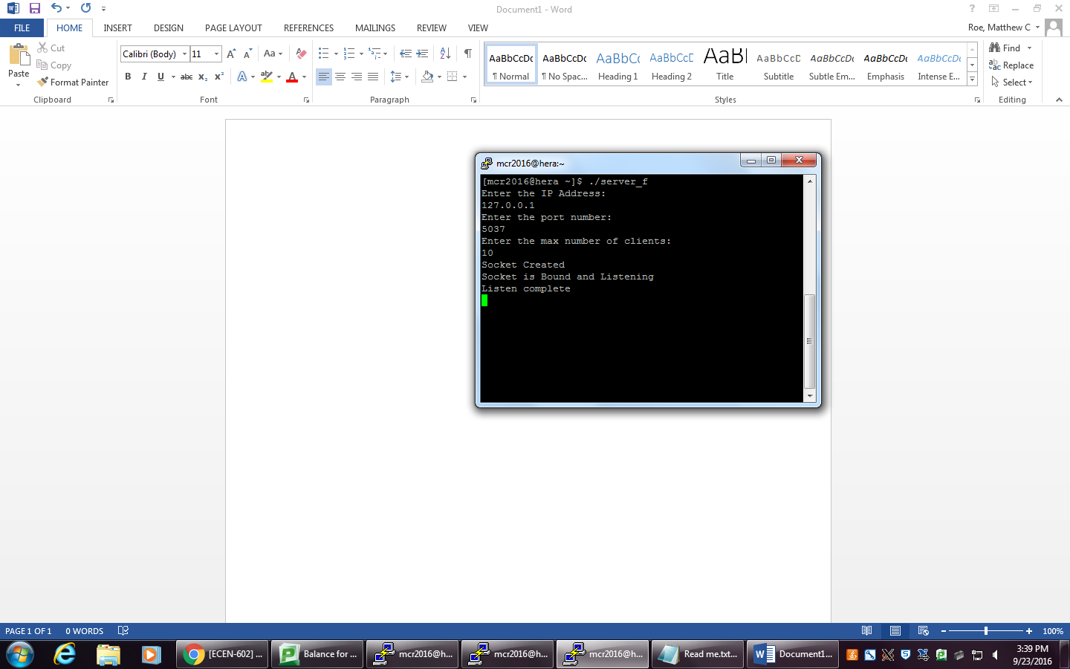

This test shows the user input from command line. It also is creating and binding the socket.

Functionality Test: 2

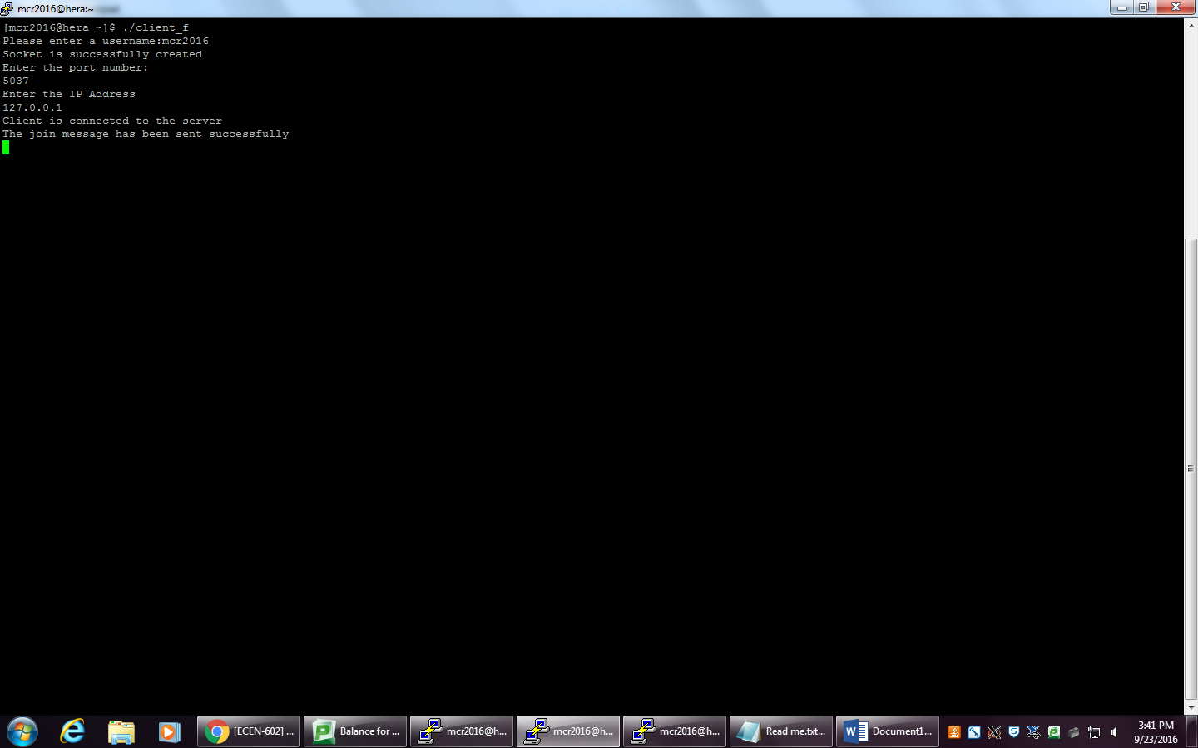

This test shows the client taking the user input from the command line. It is connecting to the same port as the server.

Functionality Test: 3

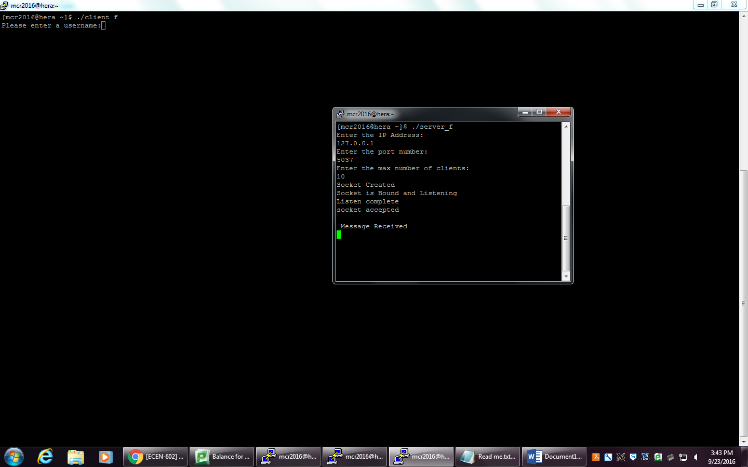

This test shows the server is accepting the clients.

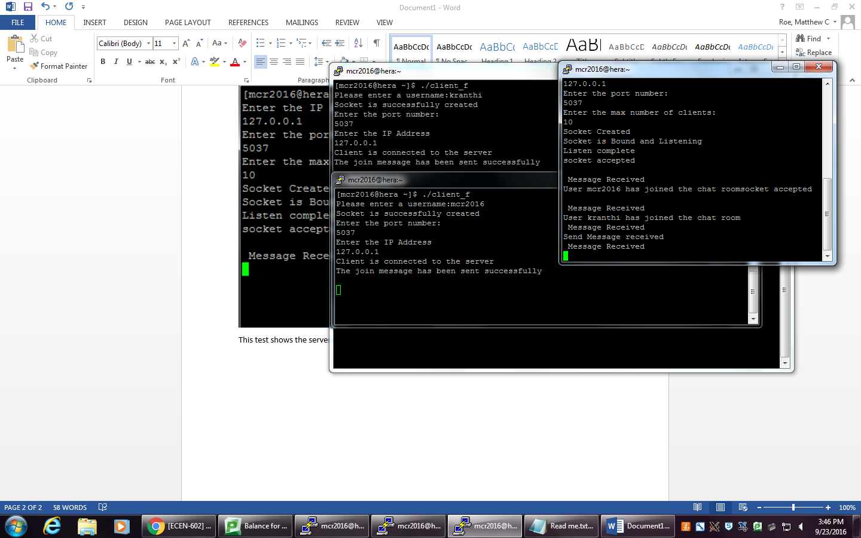

This test shows that the server can handle multiple clients.

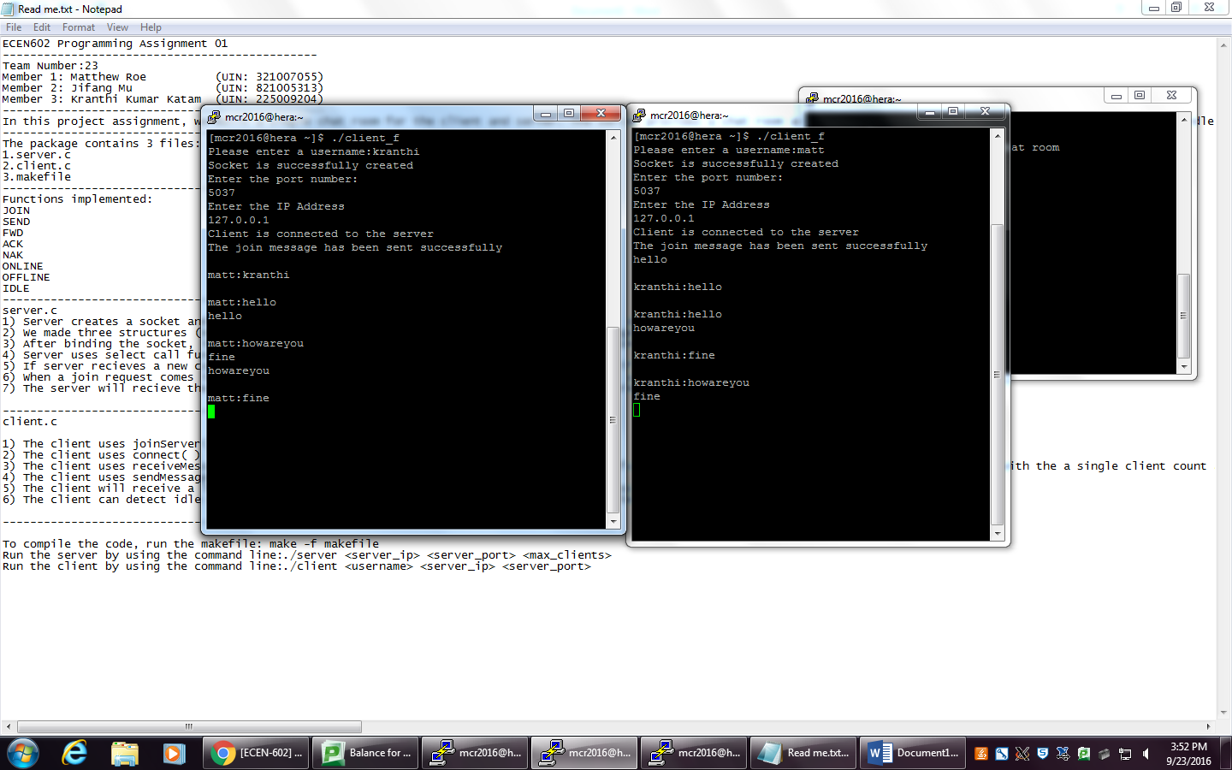

This test shows that the clients are chatting with each other.

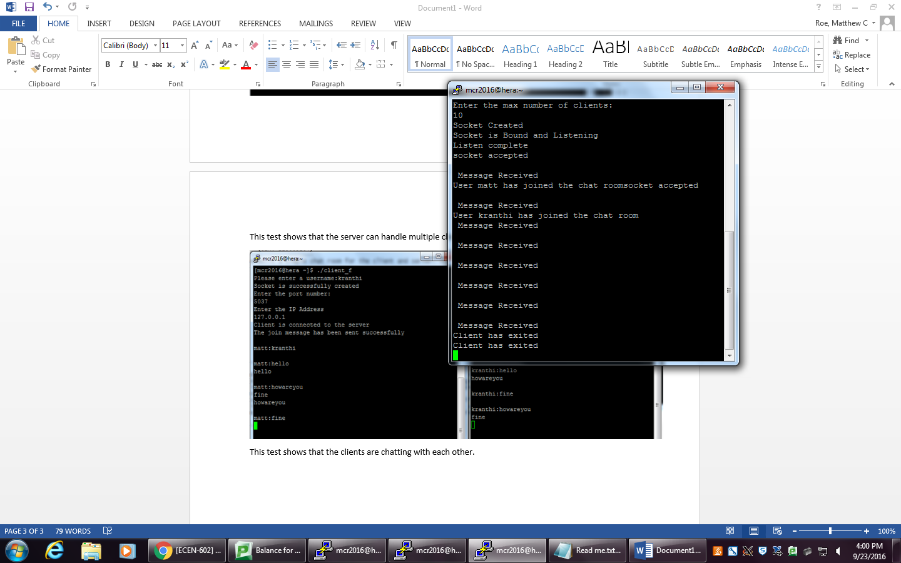

This test shows that clients disconnected from the server.